***Updated 1-27-2022 Jen Crager Rev 3***

2021-06-08 – Rev 2 – Mike Zarek

DEFINITIONS:

Build – 1 Build = 1 Network with 1 to 5 server Groups, with each Group having 1 or more VMs. Everything in your Build will be placed on the same network which will be allocated by vRA.

You have no control over the network numbering. At this time, you cannot add another server to the new network outside of your Build. The size of the network will be automatically determined by vRA based on the number of VMs you are building. You can reserve additional IP addresses in the network for later use (such as clustering).

Disk space will be automatically allocated on the vSAN. There is no need to create a LUN/CU:LDEV/Datastore.

NOTE: If any one part of your Build fails (such as a single VM creation), your entire Build is considered failed.

Group – A Group is one or more VMs defined by 4 variables: Server Nameroot, Server Size, Server Operating System, and Server Type.

If anyone (or more) of these variables change, you need another Group. You can build multiple servers in a Group, and you may have up to 5 Groups in a Build. You can have multiple groups where only one variable changes (For example, 3 Groups with the same Server Nameroot, different Server Sizes, same Server Operating System, same Server Type).

Hostname - The hostname is determined automatically by vRA, in the format: EXXXXXXXT######

Where:

E = Environment/Lifecycle (P)rd, (S)tg, (T)st, (D)ev. Prepended to Nameroot during Build process by vRA.

XXXXXXX = (7 Characters) Server Nameroot from TDD. Determined by App Team and entered by CSE in the Build form from TDD

T = Type (W – Web, A – App, D – Database, etc.) Determined by App Team and entered by CSE in the Build form from TDD

###### = 6-digit number determined by vRA during the build process. Not controllable. Appended during Build process.

App teams should preferably group servers of same spec/type (Size, OS, and Type) under the same Server Nameroot and use aliases to provide a more “friendly” name for individual servers.

BUILD PROCESS:

1. Login to PEAS jump (A46PRDSHPEASA01.PEAS.PUBLIX.COM or L17PRDSHPEASA01.PEAS.PUBLIX.COM) with your PEAS Q Account via CyberArk.
   1. You must use the FQDN to connect.
   2. Use the PEAS jump servers for all access to vRA, even if you are building a lower lifecycle server that will be considered NEAS.
   3. The PEAS or NEAS destination of the server(s) being built is determined by the “Project” selection in step 6b, below.
2. Login to VRA Console [**https://pvavra01.publix.com**](https://pvavra01.publix.com) with your PEAS Q Account
   1. Q account username only, no domain (IE: Don’t use PEAS\QXXXXXX)
   2. Chrome appears to work the best
      1. For reference, PPC vCenter links:
         1. If your VM is built in ATL you must use ATL vCenter
         2. If your VM is built in LAK you must use LAK vCenter
            1. <https://a46pnpwvca01.peas.publix.com>
            2. <https://a46pwvca01.peas.publix.com>
            3. <https://l17pnpwvca01.peas.publix.com>
            4. <https://l17pwvca01.peas.publix.com>

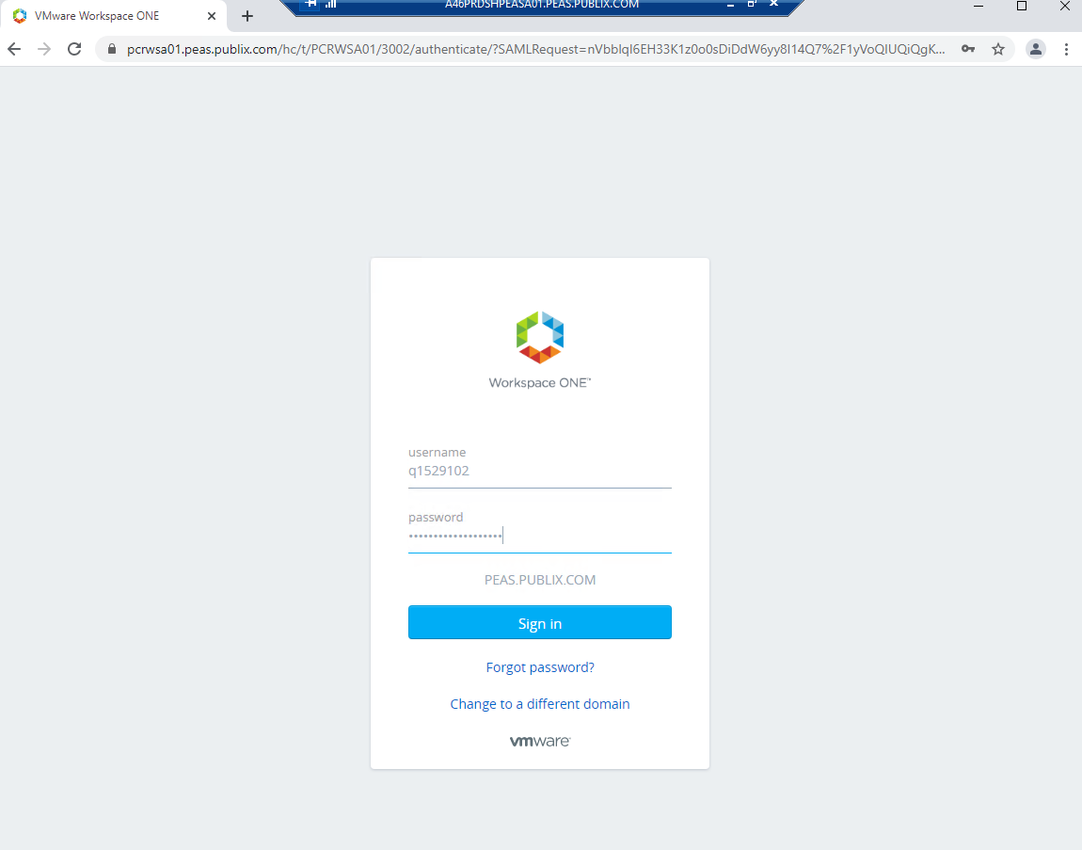

1. Click Service Broker

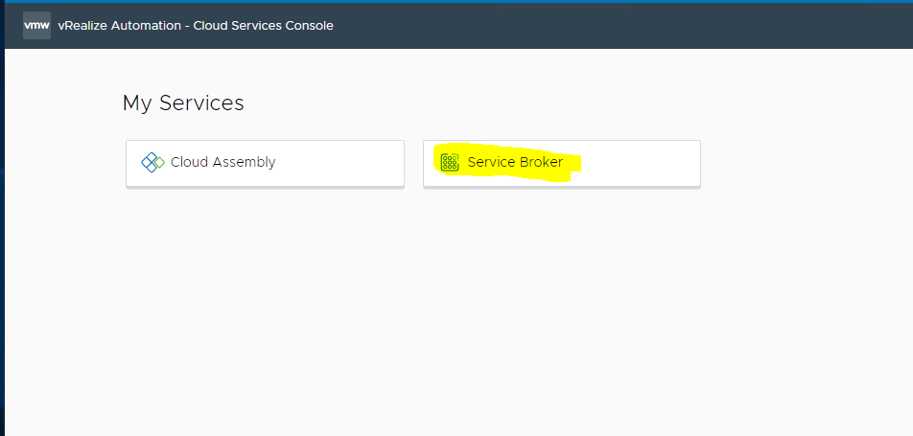

1. On the Catalog tab, click REQUEST on the tile for the number of “Windows # Groups” you require

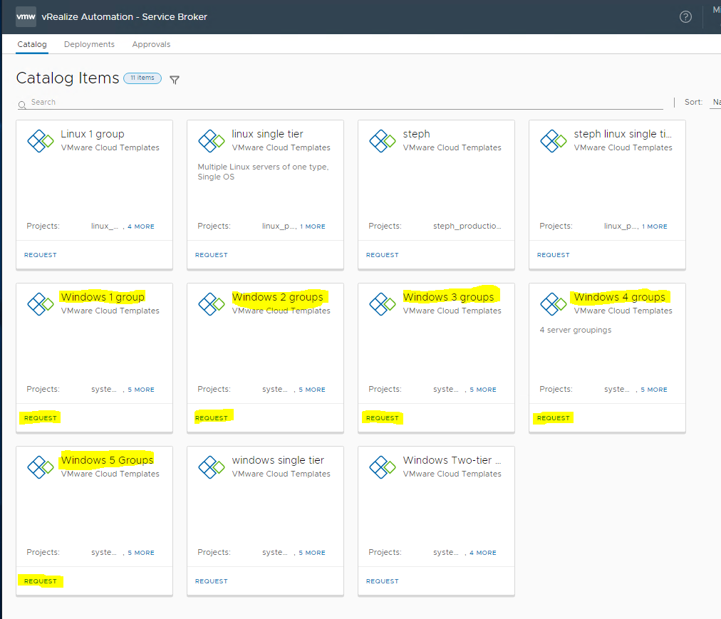

1. ON THE NEW REQUEST PAGE, DO NOT CHANGE THE “VERSION” SELECTION UNLESS DIRECTED BY THE AUTOMATION TEAM. This will always default to the approved version of the template.
2. GENERAL TAB:
   1. Enter Deployment Name – This is a just a label for our reference. Make this something you will recognize if needed down the road. You may use the “Name” listed in the TDD.
   2. Select Project from dropdown. This will either be “system engineering non-production” for ALL lower lifecycles, or “system engineering production” for PRD.
      1. Do not use any other “Project” from this dropdown unless directed by the Automation team.
      2. This selection is what determines whether the build is done in PEAS or NEAS
   3. Enter the SystemID per TDD
   4. Description – Type a description (optional)
   5. Select Lifecycle from dropdown per TDD
   6. Select AD domain from dropdown per TDD
   7. Enter number of additional IP addresses needed (if any). These IP addresses are IN ADDITION to the number of addresses calculated by vRA.
      1. Note: The “Total number of IPs” field in the form will not re-calc on the fly. It will be done once you click Submit on your Build.
      2. You only need to specify additional IP addresses if you need more than the “native” subnet of the build. For example: If you are building two servers, you are going to get a /29 network natively (Netmask 255.255.255.248, 5 useable IP addresses). If you are only building two servers that you need to cluster, you will be able to use the leftover IP addresses in the /29 network to setup the cluster. No additional IP addresses would be needed. If you were building 4 servers in this network and need to cluster two of them, you would need an additional IP address since 4 of the 5 native addresses would be taken up by servers.
   8. The Network Profile and Cloud Zone entries will be automatically filled in based on the Project you selected above. You cannot change these entries.

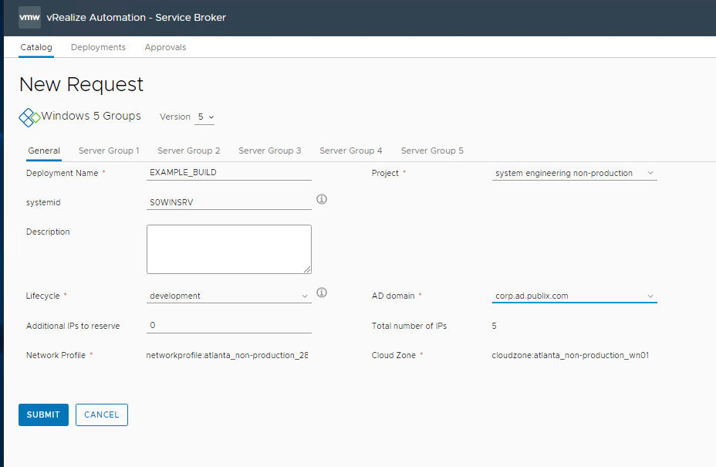

1. Server Group # tab (Complete for all Groups)
   1. Enter the Server Nameroot per TDD (Please use all lowercase)
   2. Server Size – Select from dropdown per TDD
   3. Server Operating System – Select from dropdown per TDD
   4. Server Type – Select from dropdown per TDD
   5. Number of VMs – Enter the number of VMs to build to this spec per TDD
   6. Verify the information for all Groups is correct and click SUBMIT

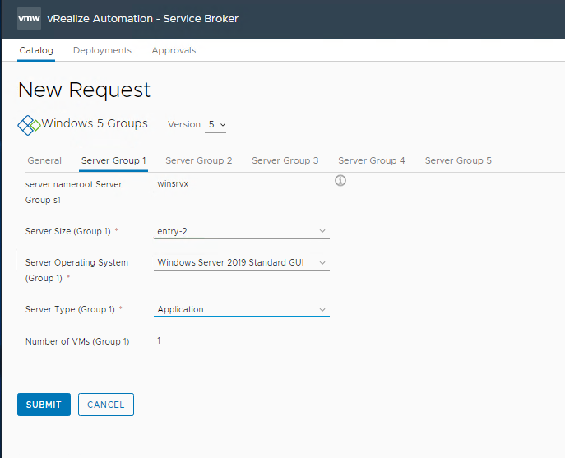

1. vRA will begin deployment and you will be automatically brought to the Deployments tab/screen
   1. If failed, use ACTIONS dropdown to Delete the failed build, preferably before trying to rebuild. Make certain you are deleting YOUR failed build. A Delete operation will be submitted for approval.
      1. Non-PRD builds: You may approve your own deletion. Navigate to the Approvals tab to approve the deletion.
      2. PRD builds: Deleting PRD builds must be approved by Arnold Johnson or Mike Zarek. They will NOT receive an automated message that a deletion is pending so please send an email/chat that you have requested a deletion.

If the Delete deployment in vRA completed successfully then there should not be much manual cleanup (except CMDB). For CMDB there is no delete option - to clean up the deleted servers from the CMDB, you must grab all the old server names and send an e-mail to I/S CMDB Support to delete them from the CMDB

* 1. This should start an automated cleanup process which will remove the VMs, Network, and AD objects.
  2. A manual cleanup can be done as far as ESX and AD go, but you cannot manually cleanup the network/InfoBlox that was created for the build. Before attempting any manual cleanup consult with Stephane/Automation Team. Otherwise we will end up with wasted network segments.
  3. You can start a new build without deleting the failed build, however this will get messy if you forget to go back and clean up. Again, please try to clean up first.

1. Click on your deployment

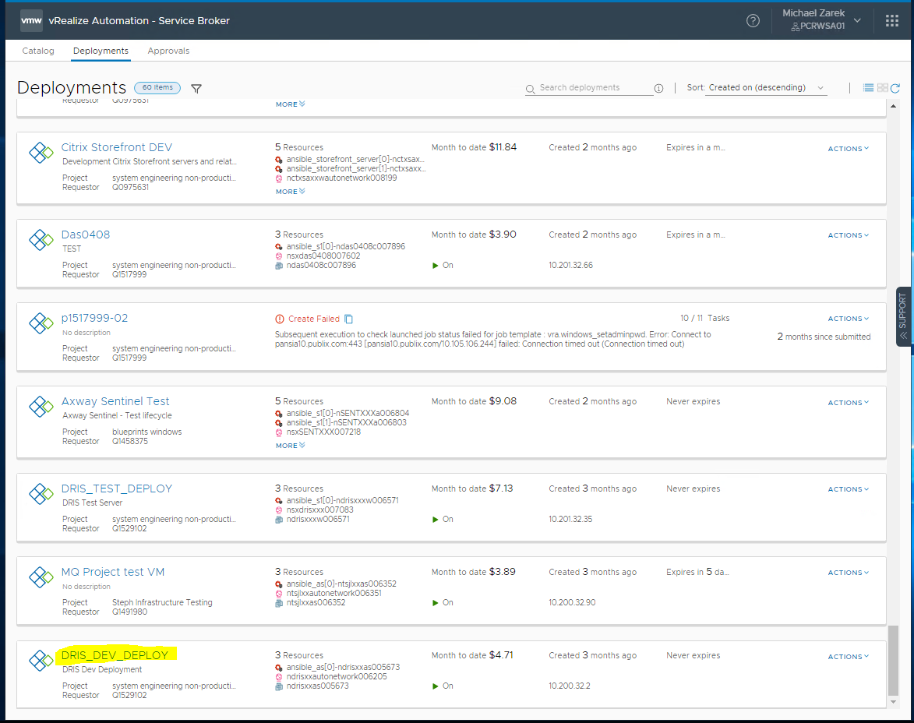

1. At 5 of # tasks you can click on the network object to see your network setting and the server object in the topology and see your hostname in the right column. (Hostname is set by the vRA build process, see DEFINITIONS section above for explanation).

You can also click on the History tab to see the individual events

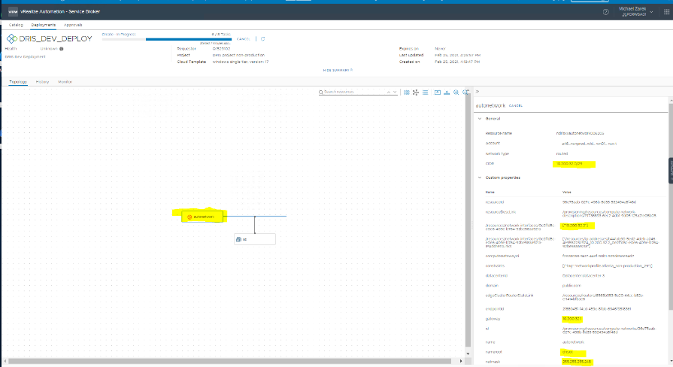

You can click on the ‘s#’ icon in the workflow to obtain info on the VM(s) being built.

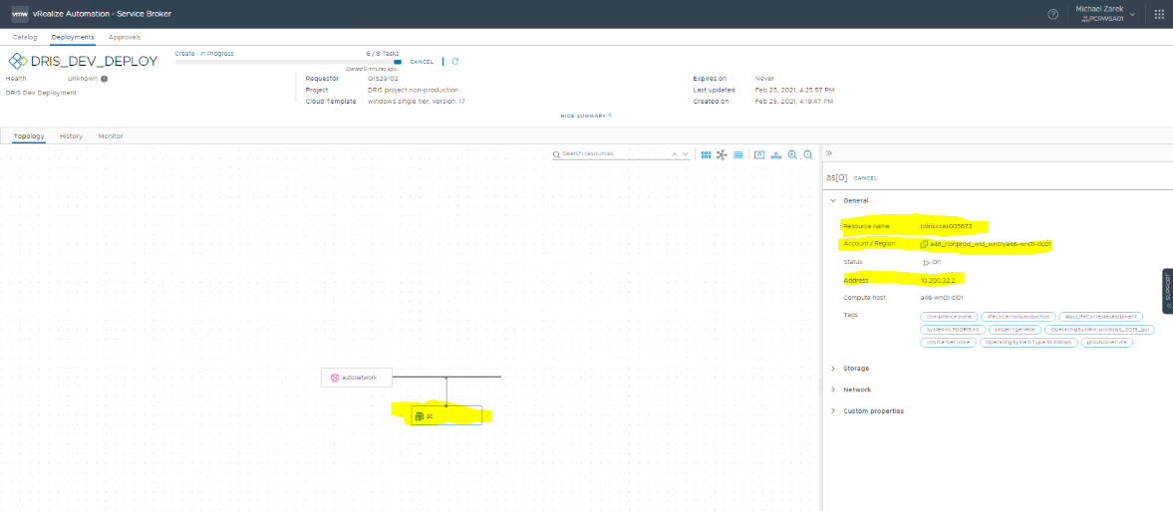

Completed

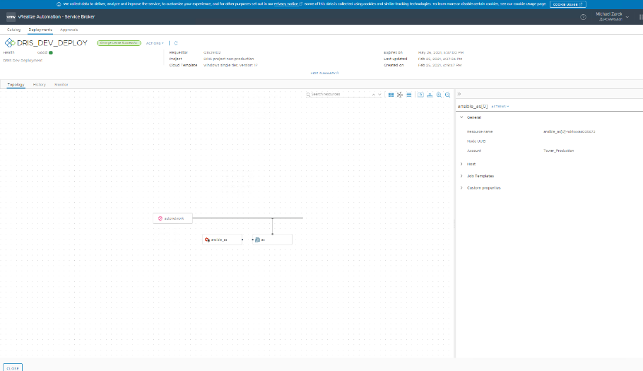

Post Build Steps

1. When builds are completed move server AD Object to final OU by normal methods (ARS). New builds get put under ServerObjects/WindowServer/Build
2. RDP to the VM(s) via CyberArk. Login to the VM and gpupdate /force and reboot. Complete the build as you would after a normal Ansible build (Post build scripts, etc. To be automated later?) ***Note: It may take 24 - 48 hours (about 2 days) to see the new servers in CyberArk.***
3. Verify that the # of CPU cores x # of CPU sockets is correct in Vcenter. (ie: 2 cores x 2 sockets = 4 vCPU). **Per Shawna ALL PPC builds are to have no more than 2 sockets until further notice.**
4. The vRA build process will only build with default C:\ and D:\ disk sizes. You will need to go in and modify these disks, and add any additional disks needed per TDD, manually in vCenter.
5. Verify entries for the VM(s) in CMDB - it will fill in some of the required details. Please verify OS, CPU, RAM, Disks, Maintenance Schedule, Relationships, etc.
6. There are notifications for server decoms but not builds so notify app team when it is completed and copy WindowsServerBuild and SUM Deployment Team. ***Note: Builds should finish fully patched unless you add software like .Net to post build.***
7. App team may need to fill out an access request to connect to new PPC servers.